**PERSON DETECTION WITH YOLO**

**Abstract**

In this project, we were asked to collect, annotate and evaluate person detection using YOLO.

The followings steps will cover the solution of the Problem :-

**STEPS :-**

1. **Image Data Collection:-** We have gathered 100 people images from **Open Images Dataset V7** which are in diverse conditions.

**Dataset link** : - <https://drive.google.com/drive/folders/1M3OUoeoC90XvvRQ6yDE9p953Bz1erk1t?usp=sharing>

1. **Data Arranging:-** Arranging the data by seeing that any unnecessary images are present or not.
2. **Annotating the Images :-** We have performed the annotation of Images using **Labellmg** and have save annotation in the **YOLO** format.

**Annotated Dataset:**- <https://drive.google.com/drive/folders/13I_uP4SrIExUpq1AFdyozppk9iXT_pMr?usp=sharing>

1. **Run YOLO Model :-** We have applied YOLOv8 Model on the 100 annotated images and have saved the prediction in the form of observations.
2. **Evaluating the model:-** we have different evaluation tools like confusion metrics, F1 Curve, precision curve, Recall curve.

**Confusion matrix :-**

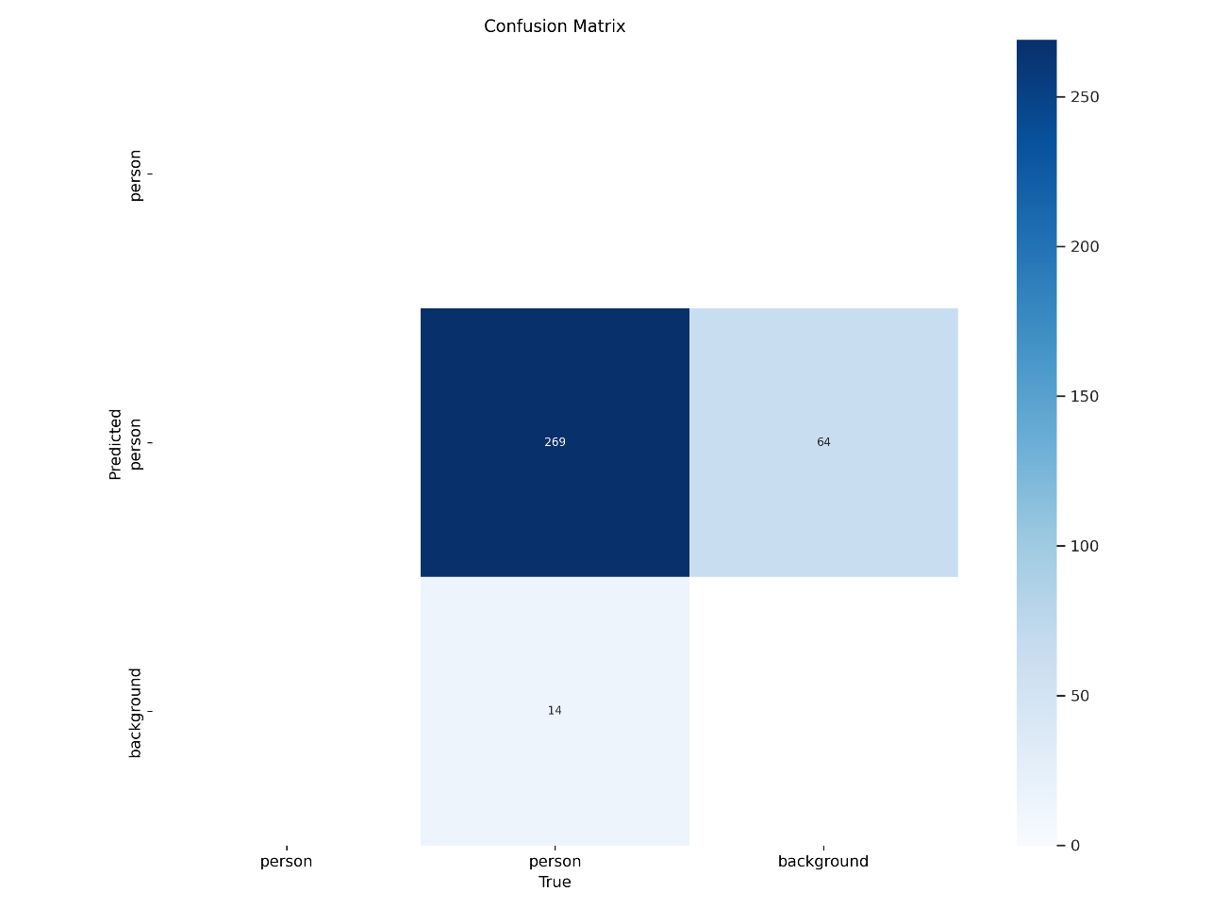

**Accuracy** = TP+TN/TN+TP+FN+FP = 269/347 = 0.77

**Error** = 1-Accuracy = 1-0.691 = 0.23

**F1 score Curve :-**

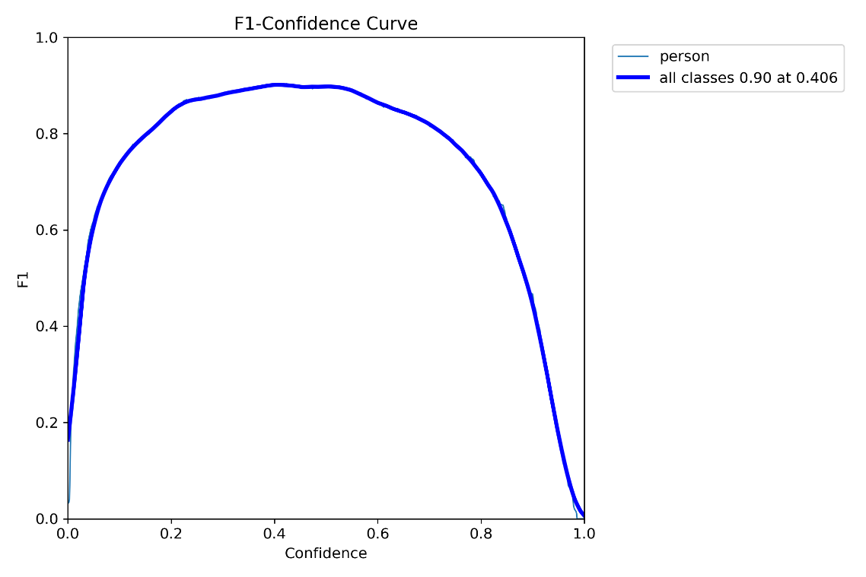

**Precision Curve :-**

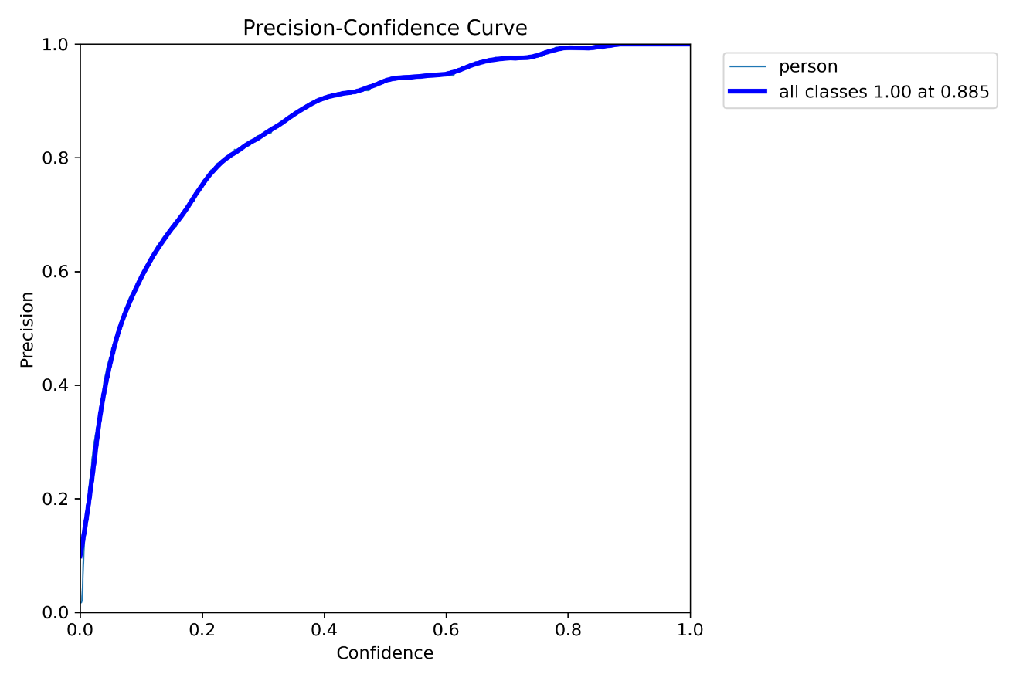

**Recall curve:-**

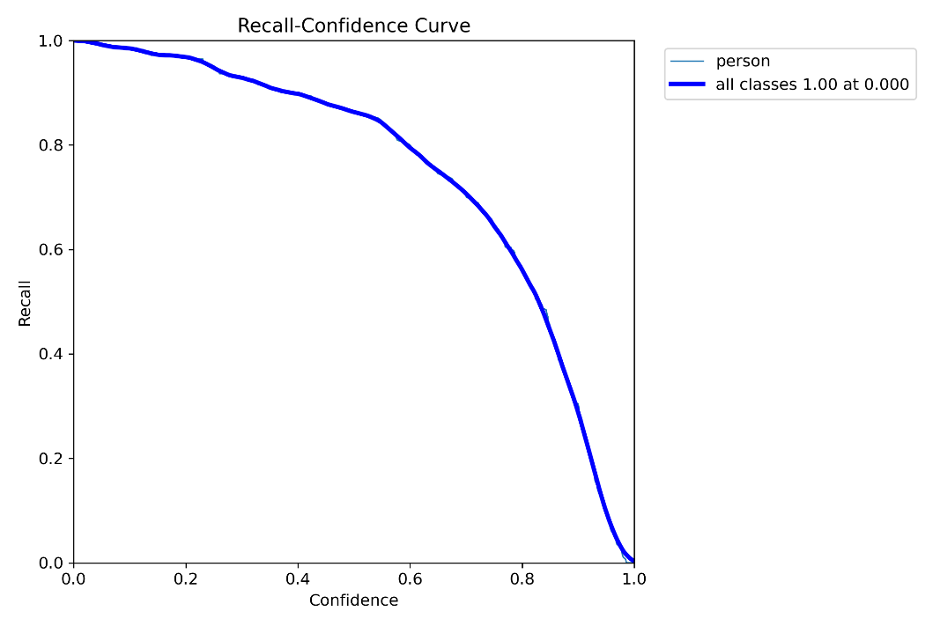

**mAP@50 Metrics : -**

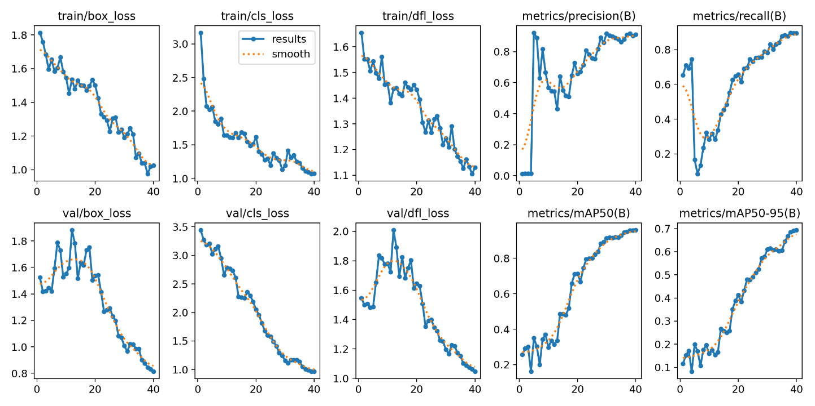

**Code or notebook used :-**

We have used Google Colab for performing the code and have saved the images and annotation in the drive and have mounted it to Google Colab.

**#Code**

**#Mount the drive**

from google.colab import drive

drive.mount('/content/gdrive')

**#Define the root directory**

ROOT_DIR = '/content/gdrive/My Drive/data'

So in drive data file contains the images and annotation.

**# Install Ultralytic**

!pip install ultralytics

**# Train model**

Here we have used YOLOv8

import os

from ultralytics import YOLO

# Load a model

model = YOLO("yolov8n.pt")  # we are loading the pre trained model

# Use the model

results = model.train(data=os.path.join(ROOT_DIR, "google_colab_config.yaml"), epochs=40)

we have used 40 epochs for training

epoch is a complete pass of a machine learning model’s training data through a learning algorithm.

*We are using a* ***YAML*** *file where we have mentioned classes of person as our dataset contains only person so that.*

**# Copy results**

!scp -r /content/runs '/content/gdrive/My Drive/data2'

We are copying the evaluation files in drive

**Whole Evaluation results are in :-**

<https://drive.google.com/drive/folders/1-4ek0E3zhygPcoGp7h6cNJckEDxfX_wG?usp=sharing>

**Some Results from the prediction :-**

EXAMPLE 1 –

Annotated Images

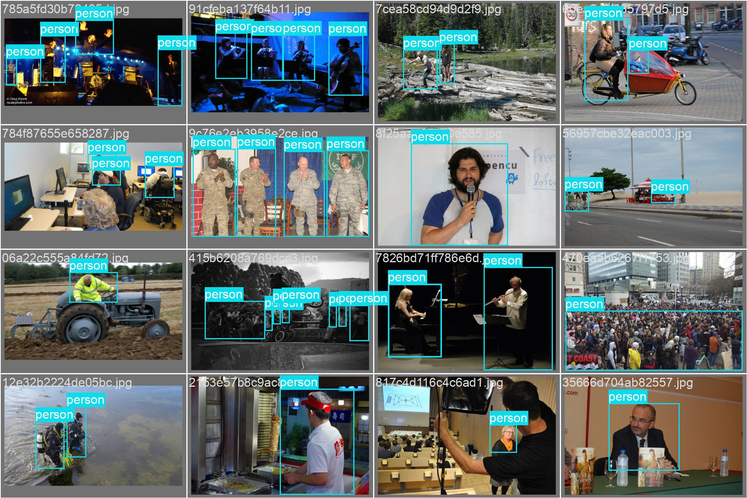

Predicted Images :-

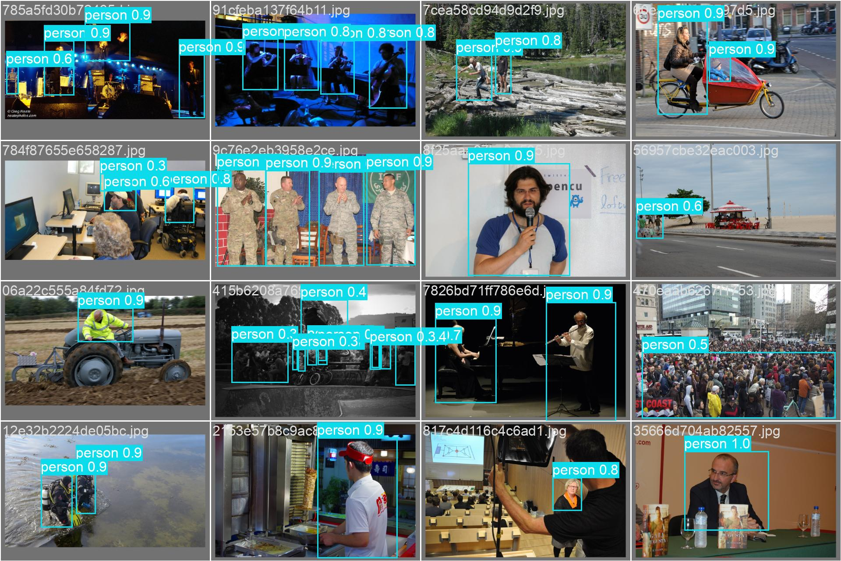

EXAMPLE 2-

Annotated Images

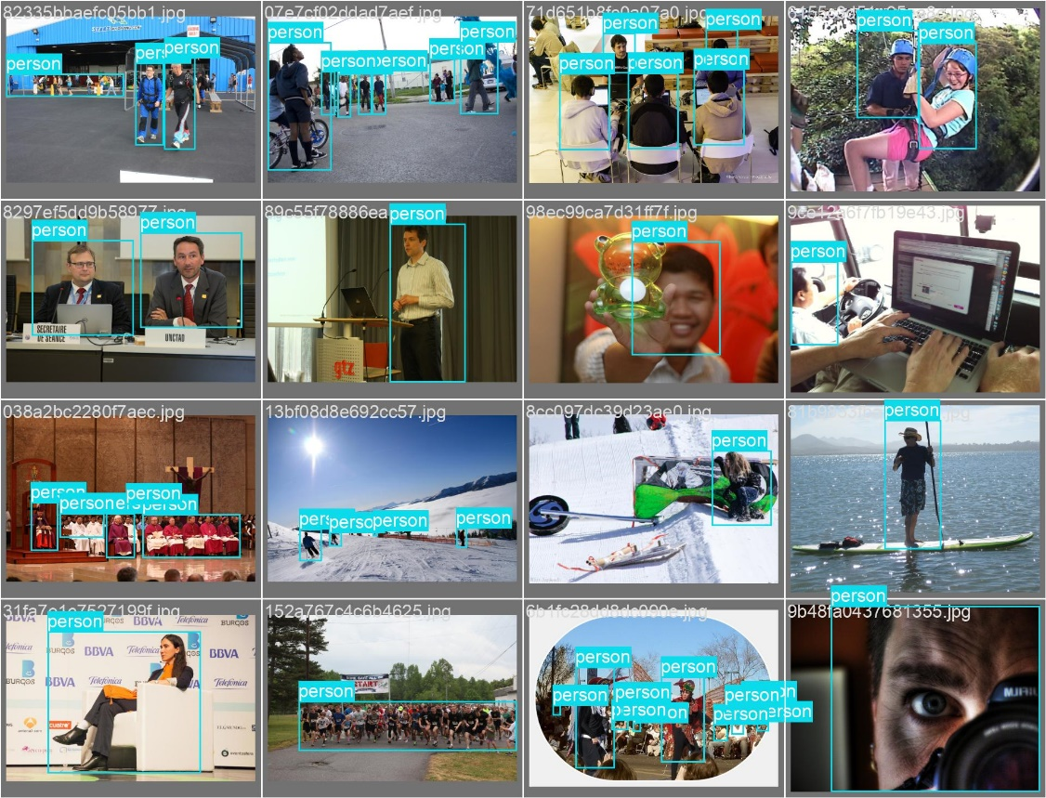

Predicted Images :-

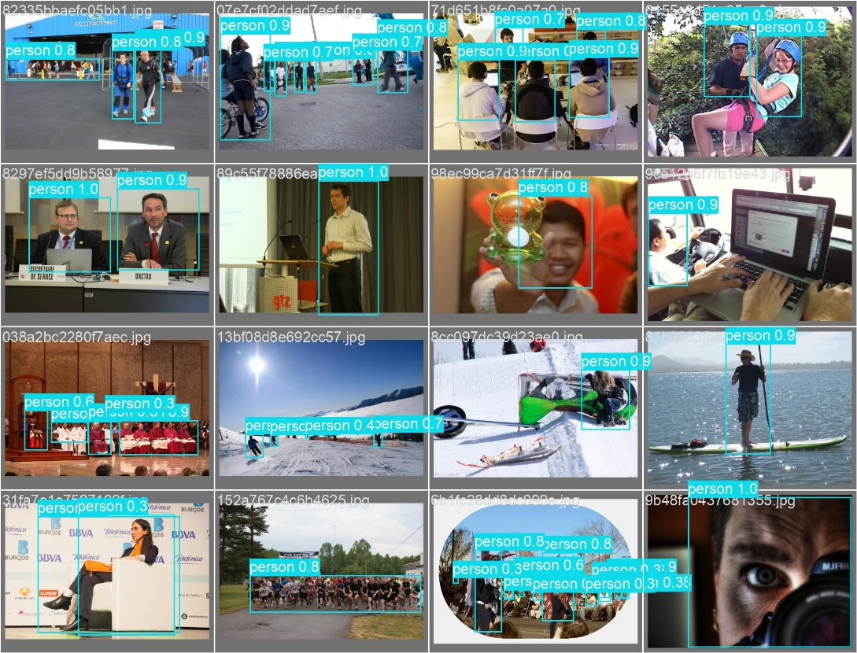

**Useful Links :-**

**Github link of the project -** <https://github.com/AliptoChoudhury/People_Detection>

**Dataset link :-**

<https://drive.google.com/drive/folders/1M3OUoeoC90XvvRQ6yDE9p953Bz1erk1t?usp=sharing>

**Annotated Dataset:**- <https://drive.google.com/drive/folders/13I_uP4SrIExUpq1AFdyozppk9iXT_pMr?usp=sharing>

**Result and evaluation Metrics :-**

<https://drive.google.com/drive/folders/1-4ek0E3zhygPcoGp7h6cNJckEDxfX_wG?usp=sharing>